Eastern Body Diary:
A Look into Race, Sex, and Dance from an Asian Bottom

The Prelude: Would You Want An Asian?
Standing on the edge of the stage, in pink overalls and a pure white shirt, I can sense the audience’s fervent attention focused on me. I always wonder what they see, an artist, a dancer, a feminine man, or an Asian. I walk on stage, with a bag in my right hand and the computer under my right armpit, to the center of the dazzling light. As I set down the bag by the table leg and the computer right at the center of the table, I begin to voice, “Alright, New York City, show me what you got,” in a provocative tone, staring at the audience interestedly. After the sentence, I flip the open the computer as, usually, a few audience will laugh here, which I am never sure about the cause. Maybe it is the way I say it. Or, is it the fact that I am reminding them of the exotic tropes permeated in the media? “Where are all the hot men here?” I climb onto the table and sit down like an ancient queen. Hearing the audience burst into laughter, I then go on voicing, “Oh, let me check out this profile.”
COMPUTER. I prefer white, Latino and middle-eastern.
PROTAGONIST. Well, OK… Next one.” [Flipping my bang.]
COMPUTER. Asian men are the hottest in the world.
PROTAGONIST. Am I? [In a rising and elongated tone.] Thank you. You’re so sweet.
What about this one.”
COMPUTER. No Asians. Just my preference. [Lying down even lower on my left
elbow and left hip, with both feet extended.]
PROTAGONIST. Alright, friend, you are missing out! [With disgust on my face.]
Oh, this one looks cute. Let me text him. Hi” [Leaning toward the computer.]
COMPUTER. Hi.
PROTAGONIST. Um… [Thinking] What are you looking for? [Excitement on the
face.]
COMPUTER. I want you to suck my dick.
PROTAGONIST. [Pause.] Okay… I can do that… But are you going to suck mine?
COMPUTER. I don’t suck dicks. I’m a top.
PROTAGONIST. Well, that’s not true. You know, [Looking up at the ceiling,
thinking.] tops also suck dicks.
COMPUTER. You suck my dick and I eat your ass. This is how it works.
PROTAGONIST. I don’t think so! [Sitting up.] You know sometimes I want my ass
eaten and sometimes… [Mumbling and interrupted.]
COMPUTER. [I look at the computer.] You must like sucking dicks because you
are a bottom. [With disgust on my face.]
PROTAGONIST. What? Seriously? I don’t particularly like sucking dicks. I mean, I
can do it but I don’t really have to do it. [With bewilderment on my face.]
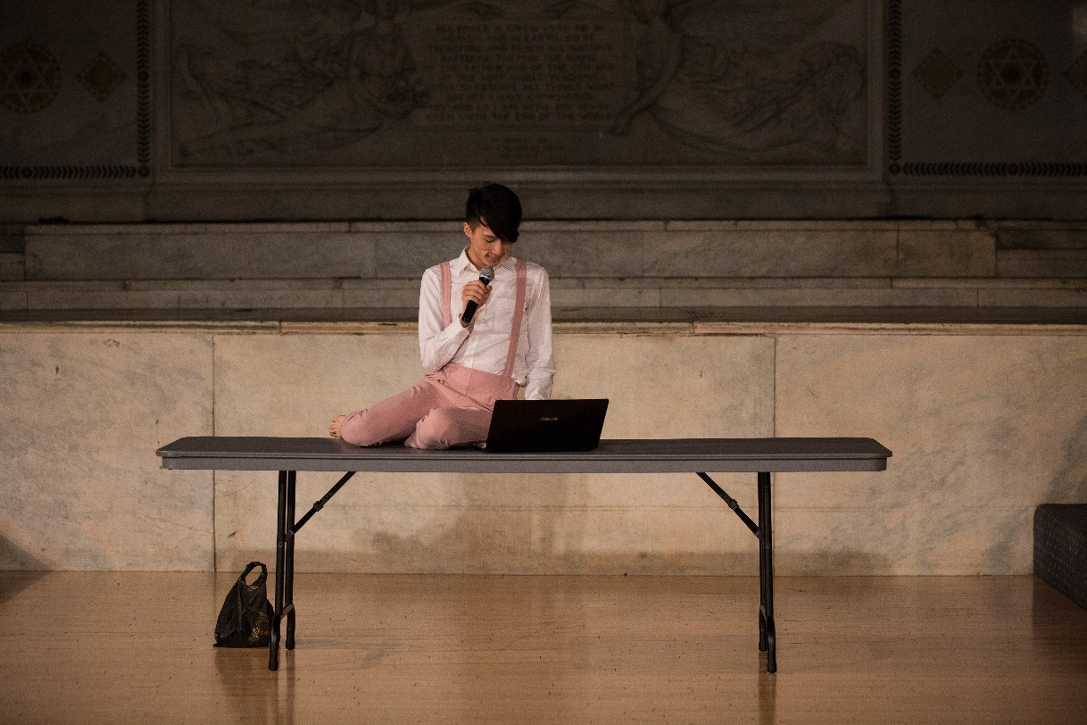
COMPUTER. I wanna fuck your Asian ass. I like submissive Asian Bottoms.
PROTAGONIST. [Pause.] What do you mean by Asian ass? Everyone has an ass. And
why does Asian have to be submissive? [Sitting low and looking at the computer
again.]
COMPUTER. Asians don’t know how to fuck.
PROTAGONIST. [Long pause.] Seriously? Of course, we know… [Sitting up and
Interrupted]
COMPUTER. You’ll like my white dick inside you. [I Look at the computer.]
PROTAGONIST. White dick? [Pause.] I don’t want your white dick inside of me. I don’t want your anything inside of me. [Pause.] What is wrong with people here? Ugh. [Closing the computer sharply.]
These are daily life interactions I have experienced since my arrival in New York City, in August 2016.
The Sex of Asians/Asian Americans
In a recent article, the website “Angry Homosexual” published its findings on gay dating preferences as evidenced in a survey of gay dating app profiles and online dating behavior in San Francisco. The study notes, “because both races [, white and Asian,] are roughly equally represented in the city, one can study their preferences for each other without having to account for Asians being a small minority, which they are in most of the US” (The Jack’d Racism Study). Astoundingly, the research revealed that 40% of gay white men are never interested in gay Asian men. On the other hand, there are only 18% of gay white men who are strongly interested in gay Asian men (The Jack’d Racism Study). While in another article, it is shown that even if they are two men with roughly the same substantive attractiveness, “28, 5’10”, 170lbs, muscular, 8”u[n]c[ut],” the gay white men get “1.5-2x more messages that the Asian counterpart (The Asian vs White). In conclusion, gay Asian men are not the preferred partners in the community, despite their numbers of population in total. Another website, OkTrends, they gave a full chart of the reply rates of nine racial groups toward one another. Gay Asian men get the lowest and the second lowest rates from gay white men and gay middle-Eastern men. Besides, gay Asian men get the fourth lowest reply rate in all the groups in average (How Your Race). This indicates how gay Asian men appear to be less preferred on the social and dating apps platforms.
Historically, in the formation of the Asian identity, it was not until 1970 that people from different Asian countries lumped together under the label “Asian”. (Leong 131) The indistinct categorization bespeaks the negligence of the multi-dimensions and facets of people with different nationalities and cultures from Asia.
The earlier dialogue in the performance registers an entire race as “unattractive and unwanted” compared to men of other races. As the conversations unfold, the power dynamics between tops and bottoms in the gay community instills. Bottoms are dismissed as penis-craving objects and their desires for either their own phallic pleasure or autonomy in performing fellatio are deprived, which reveals the monotonous imagination of bottoming pleasure in the Western context. Here the complicated interplay of the feminization of bottom as a sexual role and Asian as a race comes into play. “Asian ass,” as Richard Fung suggested, the conflation of Asian and anus (Fung, Looking for my Penis), and “submissive Asian bottoms” discourses further render Asian bodies the objects of exotic and orientalistic fetish.
Moreover, Asian men in the Western, gay or straight, are desexualized, deprived of their penile employment, thus pleasure, and subjugated to bottoming position eternally. Elaborating on Freud’s psychoanalysis, David Eng stated that the western white male subject “refuses to see at the site of the Asian male body a penis that is there to see” (Eng 2). Asian men are deemed as feminine and even female in the eyes of the west (Han 83) and the feminine penetrability (Said 206) befalls and haunts them as well.
Still, one of the nuances lurks under this first part of the performance is the accented English. The slightly yet perceivable accent existing throughout this dialogue conforms to what Nguyen Tan Hoang in his monograph A View from the Bottom coins, “accented pornography.” In the pornographic performances, actors are tokenized to create exotic settings in order to invoke and satisfy the western fetish of the oriental, primarily through accents, but at the same time, this allows the subject to create his own soundscapes and “reterritorializes… conventional scenarios with his own, overlapping soundtracks of desire” (Nguyen 64). The fact that I am speaking a rather standard English with slight accent marks simultaneously the cultural and social privilege, the ability to assimilate to the white United States, but also the racial difference, being an Asian as opposed to the white standard (Shilpa 2). Moreover, my personal standard yet accented soundtrack of desire serves as my own aspiration to blend in and, in the meantime, keeps my ethnicity and nationality within as a disidentificatory tactic “enacted by minority subjects who must work with/resist the conditions of (im)possibilities that dominant culture generates” (Muñoz 6). However, the effect of “verbal fetish” proposed by Cindy Patton exemplifies that the audience will possibly get even more satisfied when the sexual deeds accomplished are preceded by verbal requests (Patton 476). In this section of the performance, yet, my own soundtrack eventually fails to negotiate and fulfill the sexual inquiry of this racial and gender minoritarian being.
The Interlude: The Disciplined and Defiant Asian Body
After I angrily and disappointed close the computer, the cold and robotic voice-over narrates, “Asian closing the computer.” I put aside the computer and start to look at the audience, examining myself in the reflection in their eyes. “Asian staring,” is given as the audience is staring at the Asian, who puts his both hands firmly on the table. Some of them chuckle mildly. “Asian standing up” and “Asian looking around” are articulated by the monotonous white male voice. Remembering that I am being watched now, I start to fix my hair with “Asian touching the head” played in the background. Do I look good? Does this Asian look good? I am already an Asian so I have to look extra good-looking. I embark on the walk around the room, first cautiously and slowly, taking in every audience and looking at them in the eyes. Look at me. I am walking, like a person. While I am performing the walk, I scrutinize the details in the room. They are ordinary yet unfamiliar to me. My “Asian walking” gradually becomes hastier and more tensed. Turning and stumping stochastically and unrhythmically, the view in front of me starts to get blurry.
Suddenly, “Asian squatting” redirects my movement and renders me in the crouching position. The audience always laughs at this one, as a tacit agreement on this exotified and mystified term. I stay squatting there statically and then next second “Asian running” bursts as I shoot out and dash in various directions on the stage. I delineate the biggest rout I can possibly carry out with my feet and even jump over a columnar obstacle on the floor. “Asian turning left” drastically halts me to stop. I turn to my right, as my body is unable to cool down because of the energy gathered before. Then “Asian running” resumes, which compels me to sprint again. “Asian turning right” once more commands me to pause. The strap on my left shoulder slides off and my bang disheveled. A few different orders consecutively befall, “Asian turning left,” “Asian running” and “Asian falling.” In a flash, I drop to the ground with my feet high in the air, still swaying due to the momentum created before. The rest lasts less than two seconds before “Asian running” sounds again.
When I run back to the middle of the stage, a collection of random orders pour violently. “Asian turning right,” “Asian standing up,” ”Asian lying on the floor,” “Asian squatting,” “Asian looking around,” “Asian walking,” “Asian staring,” “Asian jumping,” “Asian running,” “Asian falling,” “Asian touching the head,” “Asian turning left.” Then there was a second of silence floating in the air, while I cannot stop my body from moving disorganizedly. After merely a second, the monsoon of the orders falls again. However, this time, I am unable to control my body and fail to follow the correct orders. The voice continues but I can no longer be fully conscious of what my body is implementing. In the end, after one of the myriad orders, “Asian lying on the ground,” I stay down and I am lying/dying on the floor.
Political Body and Its Narration
Throughout the whole second part, the protagonist was fighting with this representative of white male voice. The effects of language manifested here prominently, which was shown best by the opening word “Asian” in every sentence. All of the normal and daily movements, including walking and running, became marked as special objects as opposed to ordinary and standard behaviors. Language as the label and also signifier that functioned here as the primal weapon of racialization and rendered anything it referred to mystified and, moreover, inferior.
The squatting as an order and position here appeared different than most other movements. Jenny Lin in her article addressed squatting as a tool for queering the body. “Squatting is a position commonly embodied by working class people in Asia. The squatter is driven by economic necessity, by the need to wait, and to always be on call.” This performance piece alluded to the mystical term “Asian squat,” while juxtaposing it among many other Asianized terms, which made the former even more Asian and queer. An Asian queer person’s forced squatting shows here not so much the economic necessity but the social-political and cultural mission to carry out the racial mystery and minoritarian identiry as he can only rest and wait for the next order that would come up any second.
André Lepecki regards “choreography as technology for inventing movement of freedom and thinks that “bodieds become the possibilities for the political to emerge.” (Lepecki 22) In light of this, the protagonist’s interaction with the voice in this segment of the work is really a conformation to the “choreopolice”, whose “interest is movement […] that, while moving, veers away from freedom.” (Lepecki 20) At the end of this part, the protagonist fell down and could not implement any orders. Althogh not explicitly as “a persistent—even stubborn—iteration of the desire to live away from policed conformity,” his body functioned, on the other hand, as the vessel to nurture the resistance of choreopolice. Hence, the choreopolitics of Asian bodies could be expressed though this tormented scapegoat.
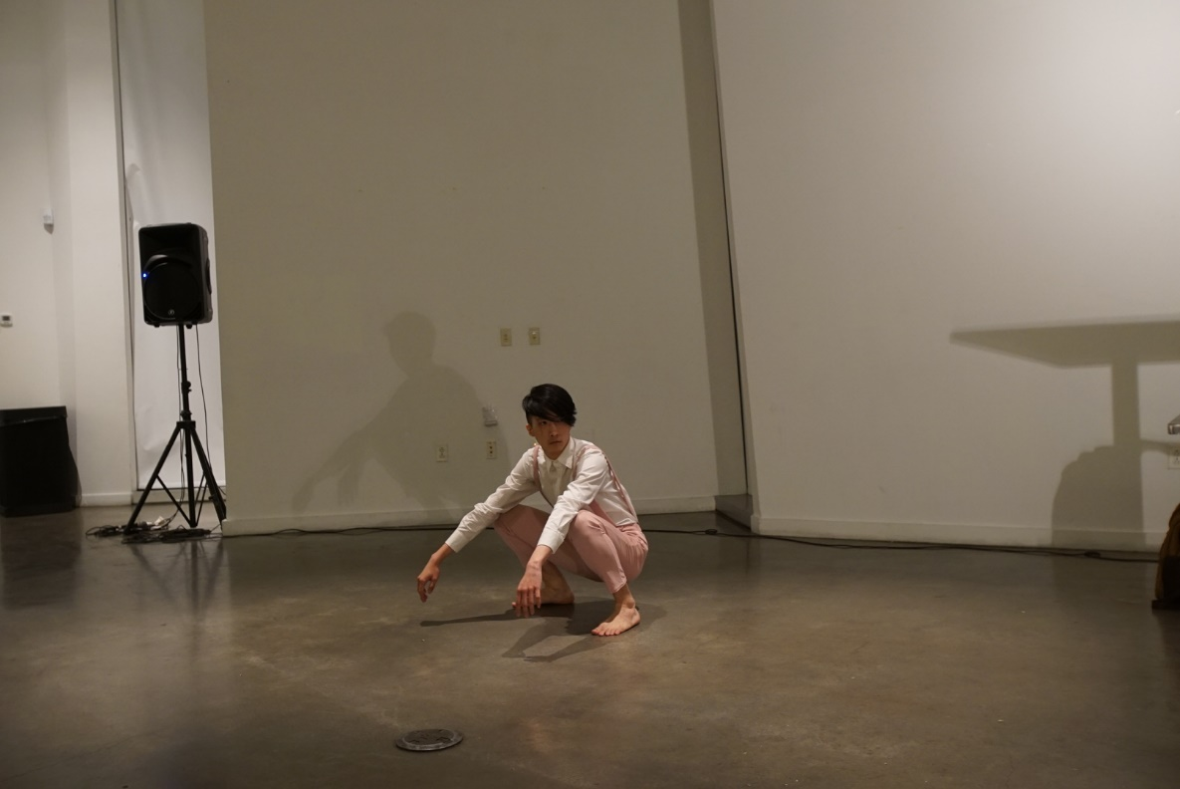
The Postlude: Can You See My Asianness?
Not long after the lying, the dreadful and repetitive word “Asian” sounds. The deep and haunting voice reverberates in the hall. I bounce up and sprint to the table, where my backpack is sitting. From the backpack, I take out a black plastic bag and put it on my head anxiously while the sound of “Asian, Asian, Asian…” is played in the background. Sitting uncollectedly on the floor behind the table, I cover my entire face with the bag. At the same time, the voice finally stops and I get to rest transiently. In the meantime, a song, My Old 125 cc Motorcycle, start to be played, which is from a Taiwanese band called “Labor Exchange.” The monologue, in the beginning, is from a Hakka mother to her son. The mother is addressing her son about

how hard life in this hyper-commercial and industrialized society is and he must work hard to make his life to the fullest so that he will succeed one day. As the monologue goes on, I am breathing inside of the bag while it is expanding and contracting eminently. I find it hard to
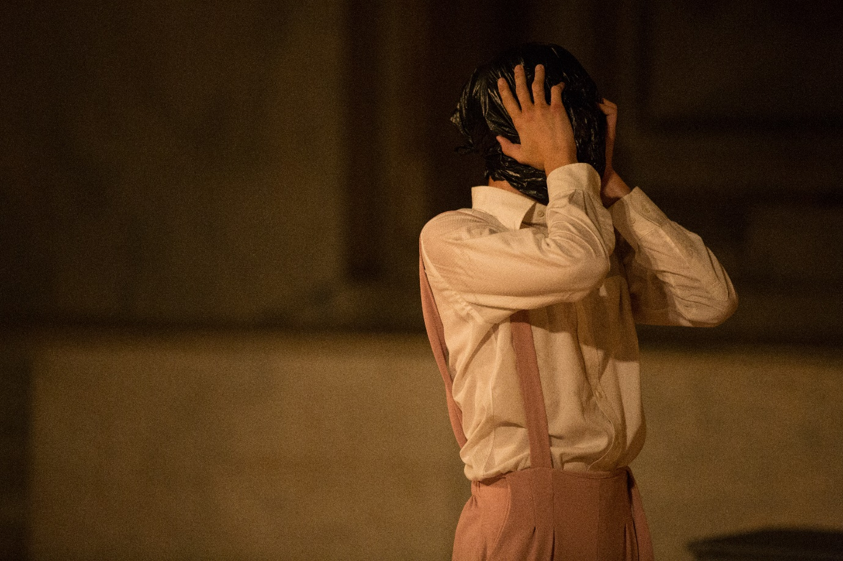
breathe so I have to calm myself down and away from the chaos happening earlier. I touch my head with my hands outside of the bag while the nostalgic tune of the song’s prelude is played by a guitar. My face feels so close yet distant and unfamiliar to me.

Gradually, I stand up and walk out from the back of the table. The vocalist, as the son who just gets addressed, starts to sing the verse:
After you saw me leaving the village, what you reminded me,
I never forget them for a moment.
But, Mother, for the past ten years, I’ve been like a wandering ghost.
I changed jobs after jobs. Sadly, none is hopeful for me.
I dated girls after girls but still couldn’t stay plural.
In this economic bubble, my life was disillusioned.
Life away from the farms and the land is full of twists and turns.
Better go home! Better go home!
Mother, please forgive me that I coming home.
I would sacrifice everything just to go back to the mountain cottages
To be a brand new person.
As he is singing passionately, I start to undress, from my left strap of the overalls, the top button to the second one on my shirt. I have to stop at the moment due to the insufficient amount of oxygen inhalation. Adjusting the bag to reveal more spaces from its connection part with my neck for air circulation, I breathe cautiously and ravenously. Finally, I reach the last button on my shirt. The upper half of the shirt is peeled off and my chest is exposed. Hunching, vulnerable and intimidated, I take off the shirt and it falls to the ground. Next second, the pink overalls are stripped down, and my blue briefs underneath get revealed. The plastic bag keeps throbbing. By the time, the vocalist gets to the part “To be a brand new person,” and I sprinkle each one of my fingers on my face and trace my cheeks, eyes, nose, temples, the back of my head and my chine. I start to breathe evidently as I walk my right hand down my right shoulder, upper arm and all the way down to the right palm, with the mother’s monologue voicing in the background again.
The fingers of my right hand stretch out and get pulled back by the left hand. Both hands fly up above my head and form a shape like a flower, or a bird stretching its wings. Then the chorus broke out, “Like this, I am riding on my old 125 cc motorcycle.” My right hand grabs my left wrist while it keeps waving like a wing. I hunker down like a bird trying to take off but fails in the end. I fall to the ground as the vocalist is singing “Farewell to this asthmatic city.” The vocalist then moves on to call out his friends names, “New Bird, Four-eyed, and Chicken Poop,” while I am bouncing and traveling on the floor in the squatting pose. “I am truly sorry,” he sings as I am twitching and trying to break free, my should and hands stretching backward and pointing high up to the ceiling. Clenching my head with two hands, I was staggering around on the floor and eventually fell onto all fours with again the lyrics of the chorus “Like this, I am riding on my old 125 cc motorcycle. Old and broken. Deafening sounds roar and reverberate everywhere.” As he is singing “What prosperity? What Future? I don’t care,” I started crawling on the floor and ended up kneeling while grabbing the plastic bag on my head, trying to breathe, even just a bit. I strived to get up but only fell back onto the floor. At this moment, the poignant sound of the Suona Horn speared through the space. I remained kneeling on the ground and my head tilted up toward the ceiling as my lungs were pressing vibrantly for more air. Tardily, I climbed up, walking, marched my legs straight and high, and then the steps gradually turned into shrugging and wriggling. After a moment of fuss, the soothing voice came back, I began creeping back to the center of the stage, to the table as he was singing:
Earth God, Earth God, your disciple begs for your grace.
Please, please. Turn of streetlights off.
No need to ask why your disciple ran back.
Earth God, Earth God, your disciple begs for your grace.
Please, please. The neighbors should turn in now.
No need for them to ask why I ran back.
No need to ask that many questions.
As the soft verse was being unfolded, I took out a banana from the bag by the table. Chuckle came out among the audience members. At that moment, I supposed I looked like a person who was worn out and needed to be energized with these white flesh in the yellow skin. Elbow resting on the table, I started peeling off this stick in my hands prudently. As its outwear fell onto the table, I caressed this handful of pulp and accommodated it with my mouth. With the bag still expanding and contracting violently on my head, the banana began to be engulfed in the black bag. I tried to chew the pulp but it was blocked out by this thin dark mask shrouded around my head. Facing down, I could feel the muddy flesh dripped onto the surface of the table. Gradually, I began to gnaw this stub faster and faster. When it got completely dissected, my face was kissing the table and my legs were dangling on the edge of it.
As the chorus flowed out again, I lifted my upper body, hand wiping off the slimy juice on the bag. Totteringly, I used my elbows and climbed onto the table top until I could place my knees abreast. Soon after I reached the position, I lay down on the table, facing the audience, with the remains of the white juice by my feet and all over my body. Next moment, I switched the position, surrendering my feet, knees, elbow and forearms on the platform. “Like this, I am riding on my old 125 cc motorcycle.” Next, while the voice was shouting out his eventual return to his hometown and calling of his friends’ names, groveling on the table, I started to jitter though the whole body as if being thrusted by some force from behind. My hands were throbbing and flapping the table. When my foot slipped, I collapsed. The next second, I propped up my bod and resumed the position. The tremor continued while the vocalist was yelling “Like this” and “Earth God” over and over. As he finished with the last sentence “I’ve also returned,” I foundered onto the surface, lying and panting. Toward the end of the song, the Suona Horn sounded again, piercing, and I moved off the table, groping out my way in the darkness in front of my eyes. Finally, I reached a concrete surface, and there was a door with a push bar on it. I kept banging the door. The loud and heavy sounds reverberated ceaselessly in the whole space, until the light dimmed the darkness devoured me completely
Naked Body: The Racial/Sexual Subjugation
In this beginning of this third part of the work, the protagonist took off his clothes slowly and melancholically, keeping only the underwear and the bag on. He utilized his body here as a tool to present his naked body, something that is devoid of any racial and sexual implication and inscription. As Agamben stated, “corporeal nakedness” is impossible to be achieved. Our bodies are perceived and evaluated by myriad factors, such as race, sex, color, height, etc. Original sin, according Agamben, settled the fate of the human body away from “purity,” nakedness. The fact that the protagonist kept his underwear on pointed out his failure to present himself as a pure body from the very beginning. He did not relinquish his humanity and, thus, also the human perspectives and perceptions of the viewers. As a result, he remained as an objects, as a nude body to be interpreted. The bag he put on concealed the most dominant mark of the race, his face and the undressing then served as his yearning for being seen as a body. However, the bag was simultaneously suffocating him, nibbling away his life energy as a human body. Erasing one’s own identity equals condemnation because one cannot live as a wholesome being. Race, as a factor in the social indexes, has already been ingrained in our cognitive programming. Elusion merely amplifies its capacity of impact on our interpersonal and intrapersonal relationships. (Identity and identification theory)
After the failure of the attempted nakedness, the image of his nudity instantly revealed “the inescapable exposure [and] vulnerability” similar to the usual feelings of the receptive parties in sex, namely a bottom in gay male encounters. (Nguyen 2) The fact that he presented himself as such and renounced any agency and attempt to dress back up manifested his submissiveness and his inescapable role as the Asian submissive bottom. David Eng in his monograph Racial Castration specifies the interwovenness of race and sexuality. The races are constantly adhesive to the ideas of femininity and masculinity. The idea of Asianness in the white west usually stands for femininity and hence it the racialized queer Asian people feminine, namely, the dominant belief of “submissive Asian bottom.”
The banana he took out stood as a racial and also ritualistic symbol in this piece. Banana is a fruit with yellow exterior and white interior, which is used as the metaphor for westernized (East) Asian persons. After the fight with the orders in the second part and moving in the bag in the first half of the third part, the protagonist went on fumbling toward the banana as if he was craving for some help from it. In this system, he had no choice but accept the ideology of this Western and white regime. The fact that there was audience laughing in the part indicates the absurdity but also the sad truth about many Asian and Asian descents’ life in this country, clumsily maintaining and balancing their life and dignity. If accepting the resources and nurturing, they are forever “fucked,” controlled, suppressed, and robbed by the system.
The fact that the protagonist covered his face meant that it could be anyone, any racially and sexually minoritarian person. This further rendered the whole last scene a sacrifice in/for this western regime. The protagonist served as the sacred but also pitiful oblation to this system that eternally others and devours people to sustain itself.

Bibliography
Albright, Ann Cooper. Choreographing Difference: The Body and Identity in Contemporary
Dance. Middletown, CT: Wesleyan UP, 1997. Print.
Agamben, Giorgio. Nudities. Stanford University Press, 2011.
Ahmed, Sara. Queer phenomenology: orientations, objects, others. Duke University Press,
2007.
Croft, Clare. Queer dance: meanings and makings. Oxford University Press, 2017.
Chambers-Letson, Joshua Takano. A race so different: performance and law in Asian
America. New York University Press, 2013.
Desmond, Jane. Dancing desires: choreographing sexualities on and off the stage. University
of Wisconsin Press, 2001.
Eng, David L. Racial castration: managing masculinity in Asian America. Duke University
Press, 2007.
Eng, David L. Feeling of Kinship: Queer Liberalism and the Racialization of Intimacy. Duke
University Press, 2010.
Han, Chong-suk. "Being an Oriental, I Could Never Be Completely a Man: Gay Asian Men
and the Intersection of Race, Gender, Sexuality, and Class" Race, Gender & Class, Vol.
13, No. 3/4, 2006, pp. 82-97.
Lim, Eng-Beng. Brown boys and rice queens spellbinding performance in the Asias. New
York University Press, 2014.
Leong, Frederick T. L., ed. Handbook of Asian American Psychology. 2nd ed. Thousand
Oaks, CA: Sage Publications, 2007. Print.
Leong, Russell, ed. Asian American Sexualities: Dimensions of the Gay and Lesbian
Experience. New York: Routledge, 1996. Print.
Muñoz, José Esteban. Cruising utopia: the then and there of queer futurity. New York
University Press, 2009.
Muñoz, José E. Disidentifications. 1994.
Nguyen, Tan Hoang. A view from the bottom: Asian American masculinity and sexual
representation. Duke University Press, 2014.
Patton, Cindy. “How to Do Things with Sounds.” Cultural Studies, Vol. 13, Issue 3, 1999.
Said, Edward W. Orientalism. New York: Vintage, 1979. Print.
Shilpa, Davé. Indian accents: brown voice and racial performance in American television and
film. University of Illinois Press, 2013.
“The Asian vs White Grindr experiment: Why it’s great to be White!” Angry Homosexual, 22
Aug. 2014, http://angryhomosexual.com/asian-vs-white-grindr-experiment-why-its-
great-to-be-white/
“The Jack’d Racism Study: Asians are as Racist as Whites.” Angry Homosexual, 15 Nov.
2014, http://angryhomosexual.com/jackd-racism-study/
“How Your Race Affects The Messages You Get.” OkTrends, 5 Oct. 2009,
https://blog.okcupid.com/index.php/your-race-affects-whether-people-write-you-back/

